Project Design Phase
Problem – Solution Fit Template

Date | 06 July 2026
Team ID
Project Name | Online Complaint Registration System
Maximum Marks | 2 Marks

Problem – Solution Fit Template
The Problem-Solution Fit explains how the proposed solution addresses existing user problems and provides a suitable approach to solve customer needs. It helps identify user challenges, understand requirements, and develop an effective digital solution.

Purpose:
- Solve complaint management problems in a way that satisfies user and organization requirements.
- Provide faster complaint registration and resolution by replacing manual complaint handling processes.
- Improve communication between users, agents, and administrators through a centralized platform.
- Increase transparency by allowing users to track complaint status and receive updates.
- Understand existing complaint handling issues and provide an efficient online solution.

Template:
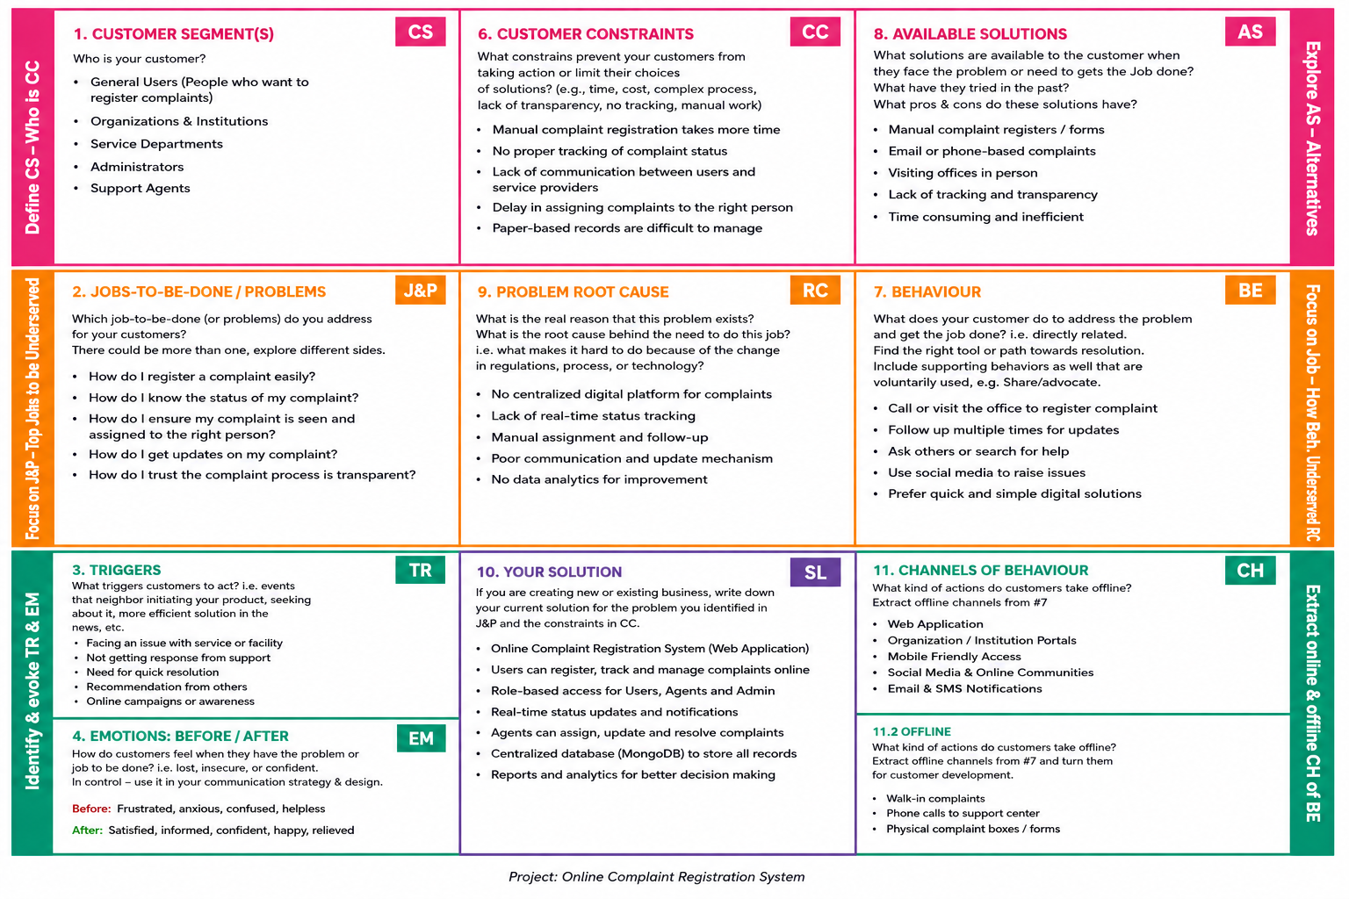
References:
- https://www.ideahackers.network/problem-solution-fit-canvas/
- https://medium.com/@epicantus/problem-solution-fit-canvas-aa3dd59cb4fe

